Christopher Bentley
Institutional Critique: Mamma Haïdara Commemorative Library – Timbuktu, Mali
Libraries, Archives & Databases: Mid-Semester Project
Spring 2011 – Dr. Shannon Mattern

The fabled city of Timbuktu has been of particular importance to Islamic scholarship and colonial myth and history alike. The remote geography of the city – situated north of the Niger River at the southern fringe of the Sahara desert in present-day Mali – limited the early presence of Western colonization and established the city as an important trade hub for the historically transient North African peoples. A perilous journey awaited any Western explorer who wished to travel to Timbuktu during the colonial era and perhaps for this very reason the city became synonymous with seclusion and remoteness. Myths were built around the city’s reputation in the Western world, which often influenced the written descriptions of the city by explorers. Consequently the travelogues and early ethnographies of the area were elaborate conglomerations of ethnocentric observation, inductive social commentary, and pre-fabricated mythology. This may have been an attempt to salvage the sentiments belonging to an earlier era of exploration – one of adventure, romance and mystery.
Perhaps contrary to the perspective of Western colonial history regarding Timbuktu are the documents stored by the Mamma Haïdara Commemorative Library and the Library of Cheick Zayni Baye of Boujbeh (both located in Timbuktu) attesting to the rich Islamic and scholarly history of the region. Prior to their incorporation into the institutional library environment, the texts – including treatises on the Qur'an, hadith, religion, mathematics, astronomy, prosody, government and history - were housed in the mud and wood scaffold mosques or at the homes of the descendents of traditional protectors of the texts. The survival of the manuscripts is in part due to the arid climate of the desert and the “hidden” nature of the city. However, this caché quality belonging to the manuscripts and their history is a Western created illusion. Many Muslims in Mali have always known about the manuscripts’ existence and Timbuktu’s status as an Islamic center for study.
The content of the manuscripts, and their importance as artifacts and historical knowledge, is undeniably valuable in the construction of this region’s historical identity. Before the manuscripts were made known to Western scholars it was generally assumed that African history was largely based on oral tradition, but the existence of the manuscripts reveal a literary scholarship stretching back centuries (at least in north-western Africa). However, at times this Western revelation seems to be on the verge of conjuring up familiar sentiments of Timbuktu’s colonial-based, ethnocentric, Western mythology. As the Chicago Tribune reported in 1999, “over 400 manuscripts have been found by Professor John Hunwick (of Northwestern) from around Africa since 1964 but the most recent find was in Mali, where the descendants of the African historian Mahmud al-Kati have been keeping them since his death in 1592”.
Once the prospect of gold and infamy, now Timbuktu yields ancient, “hidden” Islamic artifacts waiting to be “discovered” by Western scholars. The story is familiar and echoes the adventurous spirit of Western explorers in Africa from Drake to Livingstone (This is mentioned not to cast judgment or to critique scholarly exploration or competition, but as an observation of how saturated rhetoric surrounding Africa has become due to colonial history and post-colonial development industry practices). The “finding” of the Timbuktu Islamic manuscripts in 1999 opened new doors – both literally and figuratively – for scholarship in the remote city and for new environments surrounding the ancient texts. Soon after the knowledge of the manuscripts was made known to scholars throughout the world an international committee of historians, anthropologists, preservationists and Islamic scholars was formed to discuss the importance and the future of the artifacts. Libraries were constructed in Timbuktu to “properly” store the documents and increase their accessibility to local and visiting scholars and tourists. Meanwhile the manuscripts traveled the globe as an exhibition making stops at the Library of Congress and the Goldwater Library of the Metropolitan Museum of Art among other notable institutions until returning to the newly constructed library space. I traveled to Timbuktu in April of 2009 to see the manuscripts at the Mamma Haïdara Commemorative Library while serving a two-year volunteer position with the Peace Corps in central Mali.
*
The road to Timbuktu is a rutted dirt and shifting aeolian sand ribbon weaving through ancient sand dunes stabilized by sparse vegetation in the northernmost section of the Sahel – a region of arid, scrub-brush stretching from Senegal in the west to Sudan in the east. Tourists and locals begin their journey from Douentza, a truck-stop town on the main highway that cuts through Mali, and continue by bus or 4x4 north to Timbuktu. The trip is dusty and bone rattling but generally not that uncommon for travel off the main roads in Mali. The Niger River appears on the horizon after a five hour drive at which point a ferry crossing is required to reach the northern bank, the southern boundary of the Sahara and the southern city limit of Timbuktu.
As a kid growing up in rural Utah I always dreamed of traveling to the Sahara and Timbuktu to ride a camel through the desert. Like many Americans, my idea of the fabled city was largely a hyper-romanticized conglomeration of explorer’s tales and epic movies like Lawrence of Arabia and Indiana Jones (neither of which I realize ever traveled to Timbuktu). After living in Mali for nearly two years and hearing stories about the city, seeing a few pictures taken by European ex-pats and fellow volunteers, I constructed a better understanding what to expect. However, I was still surprised to find the city with comparable infrastructure – paved roads, electricity and even a streetlight or two – to some of Mali’s more developed cities.
Most of Timbuktu’s Western visitors, like myself, opt to make the journey harder than necessary by taking the overland route by 4x4 and/or bus (the place is visited because it is notoriously hard to get to right?). Timbuktu is in fact easier to reach by riverboat– large steamers with sleeping chambers and viewing decks – in the rainy season, or by plane. Flights from Paris and Marseilles arrive daily in Timbuktu during the peak tourist season between November and March via Point-Afrique Airlines. Even though it might be easier to reach than in the days of French explorer René Caillié, the first Westerner to visit and return alive from Timbuktu, the city is still a fascinating combination of northern, Berber influenced Africa and sub-Saharan Africa, composed of mainly Bambara, Mande, Fulani and Songhay cultures.
After visiting the madrassa and the grand mosque in the center of the city –centuries old structures incorporating sub-Saharan and Moroccan-style architecture – I found the Mamma Haïdara Library unassuming. The concrete and cinder block concession (a compound consisting of a large courtyard surrounded by structures) I immediately recognized as the ubiquitous architecture associated with government administration offices and large international NGO hubs, in other words an institution with money. The entrance to the manuscript library is tucked in a corner building under a covered walkway. Two Malian men sat near the door preparing tea over open coals in a wire basket. I was greeted warmly and after exchanging a few jokes was asked to pay a fee to see the manuscripts. The fee to enter the library was negotiable – like most things in Mali – but a requested donation of 1500 CFA, or about $3, was suggested. Inside the heavy metal door is a modest single room lined with the wooden shelves where most of the manuscripts are held. In the middle of the room is a waist-high wood and glass display table with a selection of Islamic manuscripts accompanied by handwritten labels in French and Arabic. Apart from the manuscripts in the display case there is little to examine. The texts in the shelves lining the room are barely visible behind the glass and wire-mesh doors that remain closed and locked. I was free to take a few pictures – at no extra cost – and after a few minutes I asked if I could see a manuscript from the shelf. I was surprised when the librarian nodded, removed a manuscript from the shelf and from its protective box and held it out for me to take. The age of the manuscript, its history and fragile state prevented me from taking it from his hands. He finally smiled and placed the manuscript on the display case where we looked through its pages while he explained the origin and significance of the text.
Upon leaving Timbuktu a few days later – after fulfilling that childhood desire to ride a camel and camp in the Sahara desert – I began processing my experience at the Mamma Haïdara Library. I found the institution increasingly perplexing. It seemed to have all the hallmarks of international investment yet the material of the library was treated in a very casual manner. I found it difficult to balance the potential value the manuscripts may yield to scholarship with the internationally funded institutional practice of swooping in, building tangible monuments to donors’ generosity and skipping town – a tactic foreign aid and development organizations have mastered.
An Andrew Mellon Foundation Grant obtained by a team of conservators, researchers, scholars, and UNESCO members from France, USA, Germany and Norway funded the construction of the Mamma Haïdara Library. Together with members of the Malian government the library structure was completed. I have no doubt that the intentions of the international team were ultimately benevolent and the construction of the library was to ensure the preservation and access to the manuscripts. My worry lies in the sustainability of the project and the effect it may have on the community.
Without straying too far into a critique of the Development and International Aid Industry, I would like to illustrate some potential problems that may arise from the movement of Islamic manuscripts to an internationally funded institutional space. There are two main issues that have the potential of being problematic. The first involves access.
The newly constructed libraries of Timbuktu are built, as previously stated, to store the manuscripts in a space that ensures their preservation in the years to come. This motive alone could be critiqued; however, the greater problem is the potential of this action to exclude local scholars from accessing the manuscripts. The library may use a sliding scale when it comes to admission prices for research of the manuscripts, but the audience the new libraries are favoring seems to be foreign one. This is an institution constructed by foreign scholars for foreign scholars. While this is an improvement over the colonial practice of removing cultural artifacts from occupied regions, it is still a display of power and wealth that removes the manuscripts from their previous associations (with the descendents of the historian who started the collection) and places them in a sterile, secure, new environment that greater resembles Western methods of organization than Malian.
The second issue is also related to access but comments more on the state of the Malian economy and its reliance on foreign aid. The creation of any foreign funded institution in Mali is an opportunity for the local and surrounding population to gain employment. Outside of running a small store or vending table at the market, most Malians function as subsistence farmers or herders. In an economy that offers very little employment, yet provides means for education, jobs with foreign institutions are coveted and aggressively pursued. Even landing a job as a guard at an NGO compound increases the status and lifestyle of an individual. These opportunities have become intertwined with the economy of villages, towns, regions and the nation. While this may seem to be advantageous to the people, it is in fact a terrible consolation. Outside aid accounts for a large percentage of Mali’s GNP and reveals the truth about the Aid Industry: in short, it isn’t working. Malians are obliged to compete for these positions while the foreign industry built around “benevolence” grows. Federal programs in Mali, because of the government’s saturation of foreign money, do little to create new jobs. The country functions with a crutch when the goal of aid organizations should be just that: aid, not means.
This ties into the problem at large in Mali and across the African continent. Outside, foreign funded programs with little or no inclusion of Malians in their process – including financial responsibility from Malians – devalue the very project that was initially created to help. I am not arguing that this happens across the board but it is common, and I speak from experience. The creation of the Islamic manuscript libraries could ultimately devaluate the artifacts, from religious and cultural signifiers to commodities. Once the libraries and manuscripts are viewed only in their relation to the tourist industry their cultural value to the people of Timbuktu could diminish greatly. In turn, this could lead to a relationship based on exchange value rather than cultural and spiritual value. The preservation of commodities and the preservation of artifacts that represent historical, religious and symbolic value are two very divergent practices.
Of course, there is no easy solution to the proposed paradigm. For the Malians of Timbuktu to remain isolationist and protective of the manuscripts is neither realistic nor possible in the contemporary, globally connected world. One method would be to weigh the pros and cons regarding the space and function of the new institutionalized Mamma Haidara Library:

The accessibility to the Islamic manuscripts by scholars from around the world provides a greater understanding of the history of Islam and the history of the region – versus – the possible exclusion of local scholars and faithful Muslims by the institutional environment and the commodification of their culture and history.
The increased tourism the impoverished region generates from visiting scholars and curious tourists will improve the local economy – versus – increased tourism’s potential to exacerbate the commodification of culture and history leading to the devaluation of culture into monetary expression.

Deciphering benefit from detriment in a case like this also depends on the method by which one decides which artifacts are valuable to a specific people and which are not: Who gets to make this decision? Often this decision is taken out of the hands of those experiencing the hardship and into the hands of an influential post-colonial presence that justify their actions under the guise of benevolence. This leads to an ultimately greater dilemma: the continued subjugation of history and culture belonging to those deemed unfit or unable to preserve, advance or help themselves. This is unfortunately a widespread, underlying, often knee-jerk perspective of Africans in general, and one that has been imposed on them for so long that they have started to believe it as truth.

* * *

This essay is obviously an experientially based critique. It encapsulates many of my experiences and situates them in context with the phenomenon of the Islamic manuscript libraries of Timbuktu. Issues of identity, the Other, the International Aid Development Complex, neo-colonial imperialism, scholarship, African anthropology, and cultural tourism are all at play here. These are issues too complex and important to summarize, but I hope it brings a fresh perspective to a discourse that seems increasingly didactic at best, and hopeless at worst.

I would like to cite Ann Stoler’s article Colonial Archives and the Arts of Governance, for helping me process the idea of the colonial archive and its influence on post-colonial models. When assessing the anthropological integrity of utilizing the archive, Stoler emphasizes that particular attention needs to be paid to the process and function of the archive, in addition to the artifacts present in their collections. This is fundamental to the critique of post-colonial archives (and archives in general) and this insight opened areas of critique that I applied to the perspective shared in this essay.

Appendix:
Photographs of Tombouctou [Timbuktu]
by Christopher Bentley

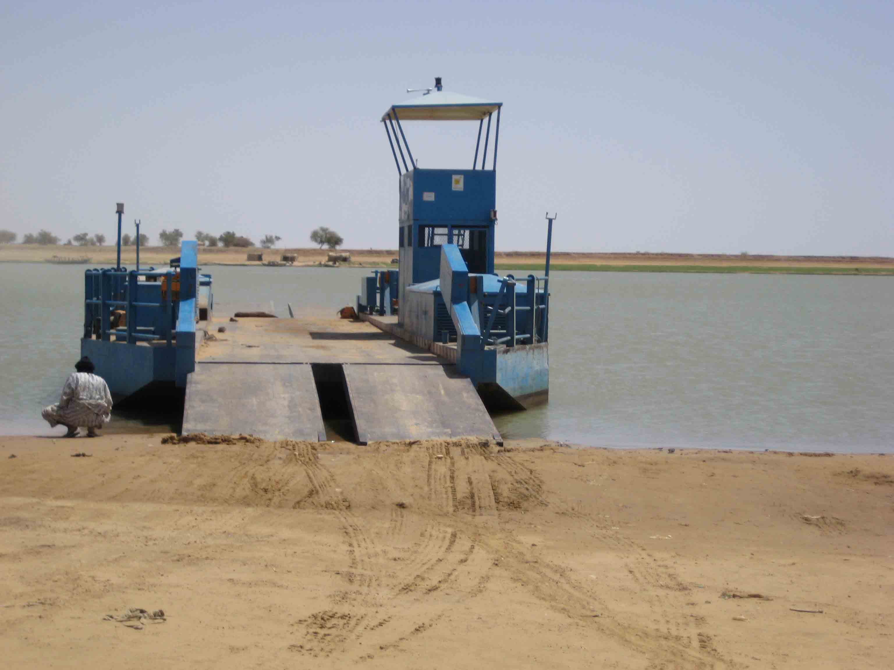
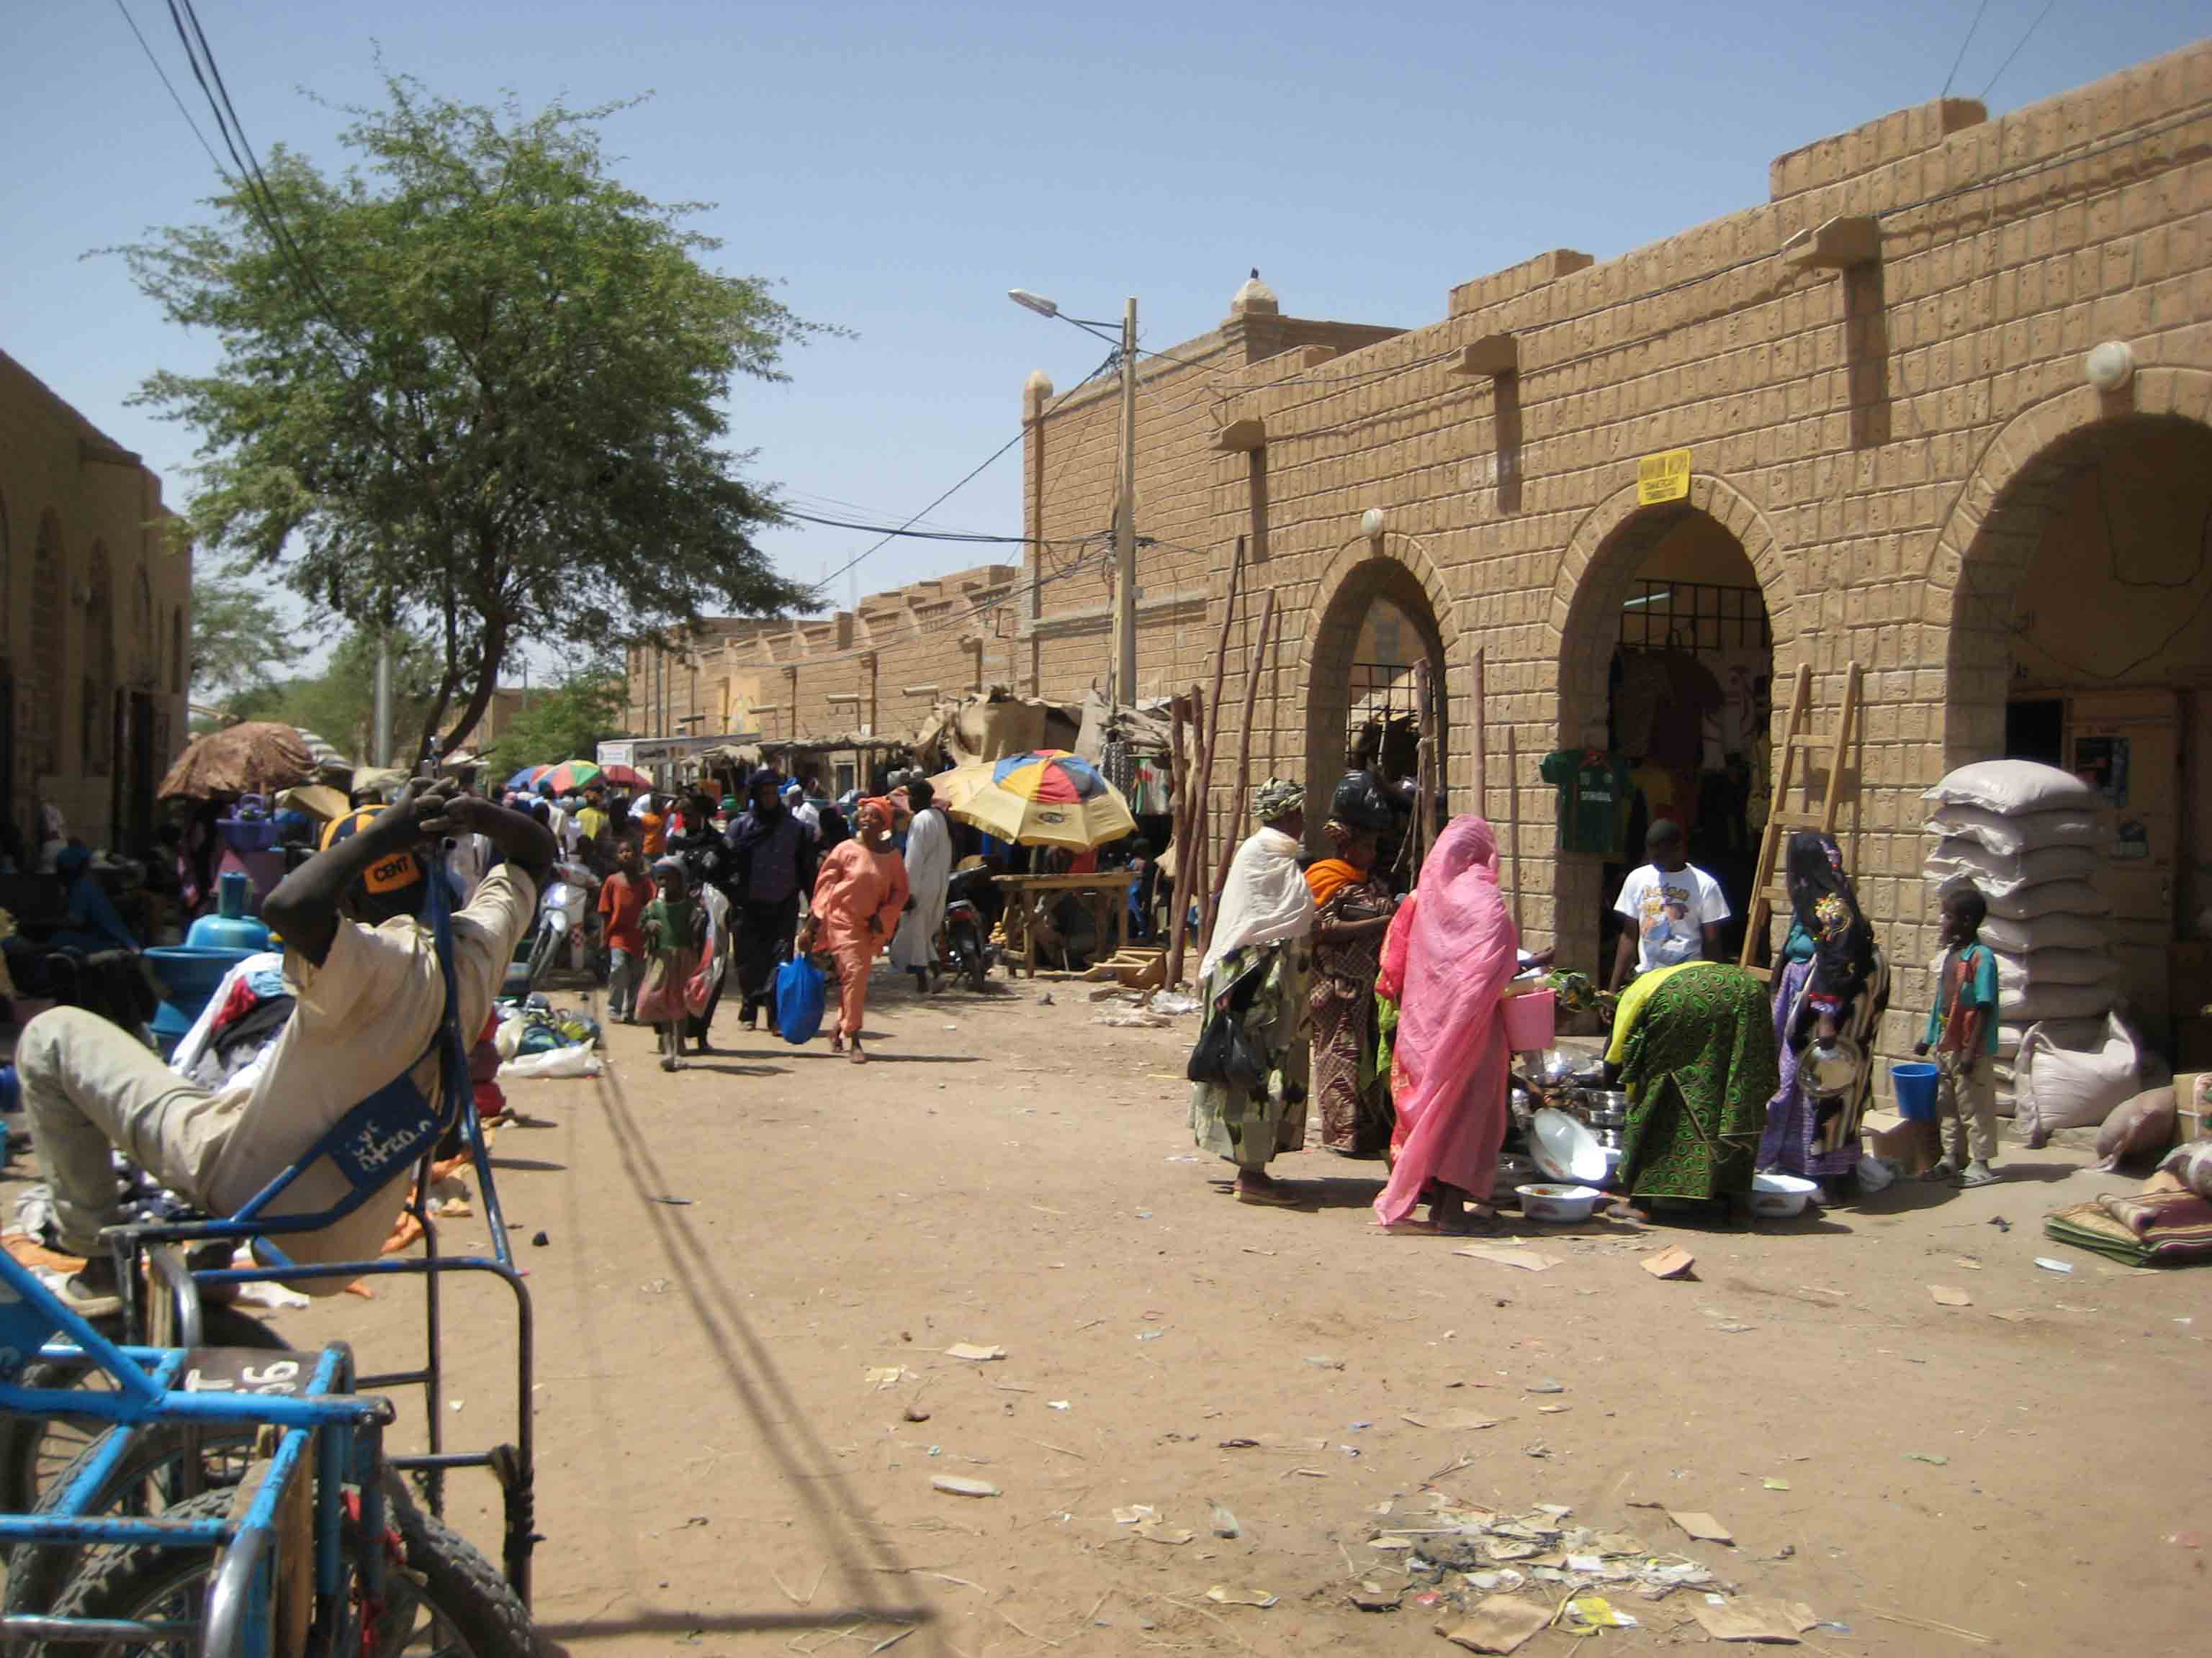

Looking south from the north bank of
The market
the Niger upon arrival in Timbuktu
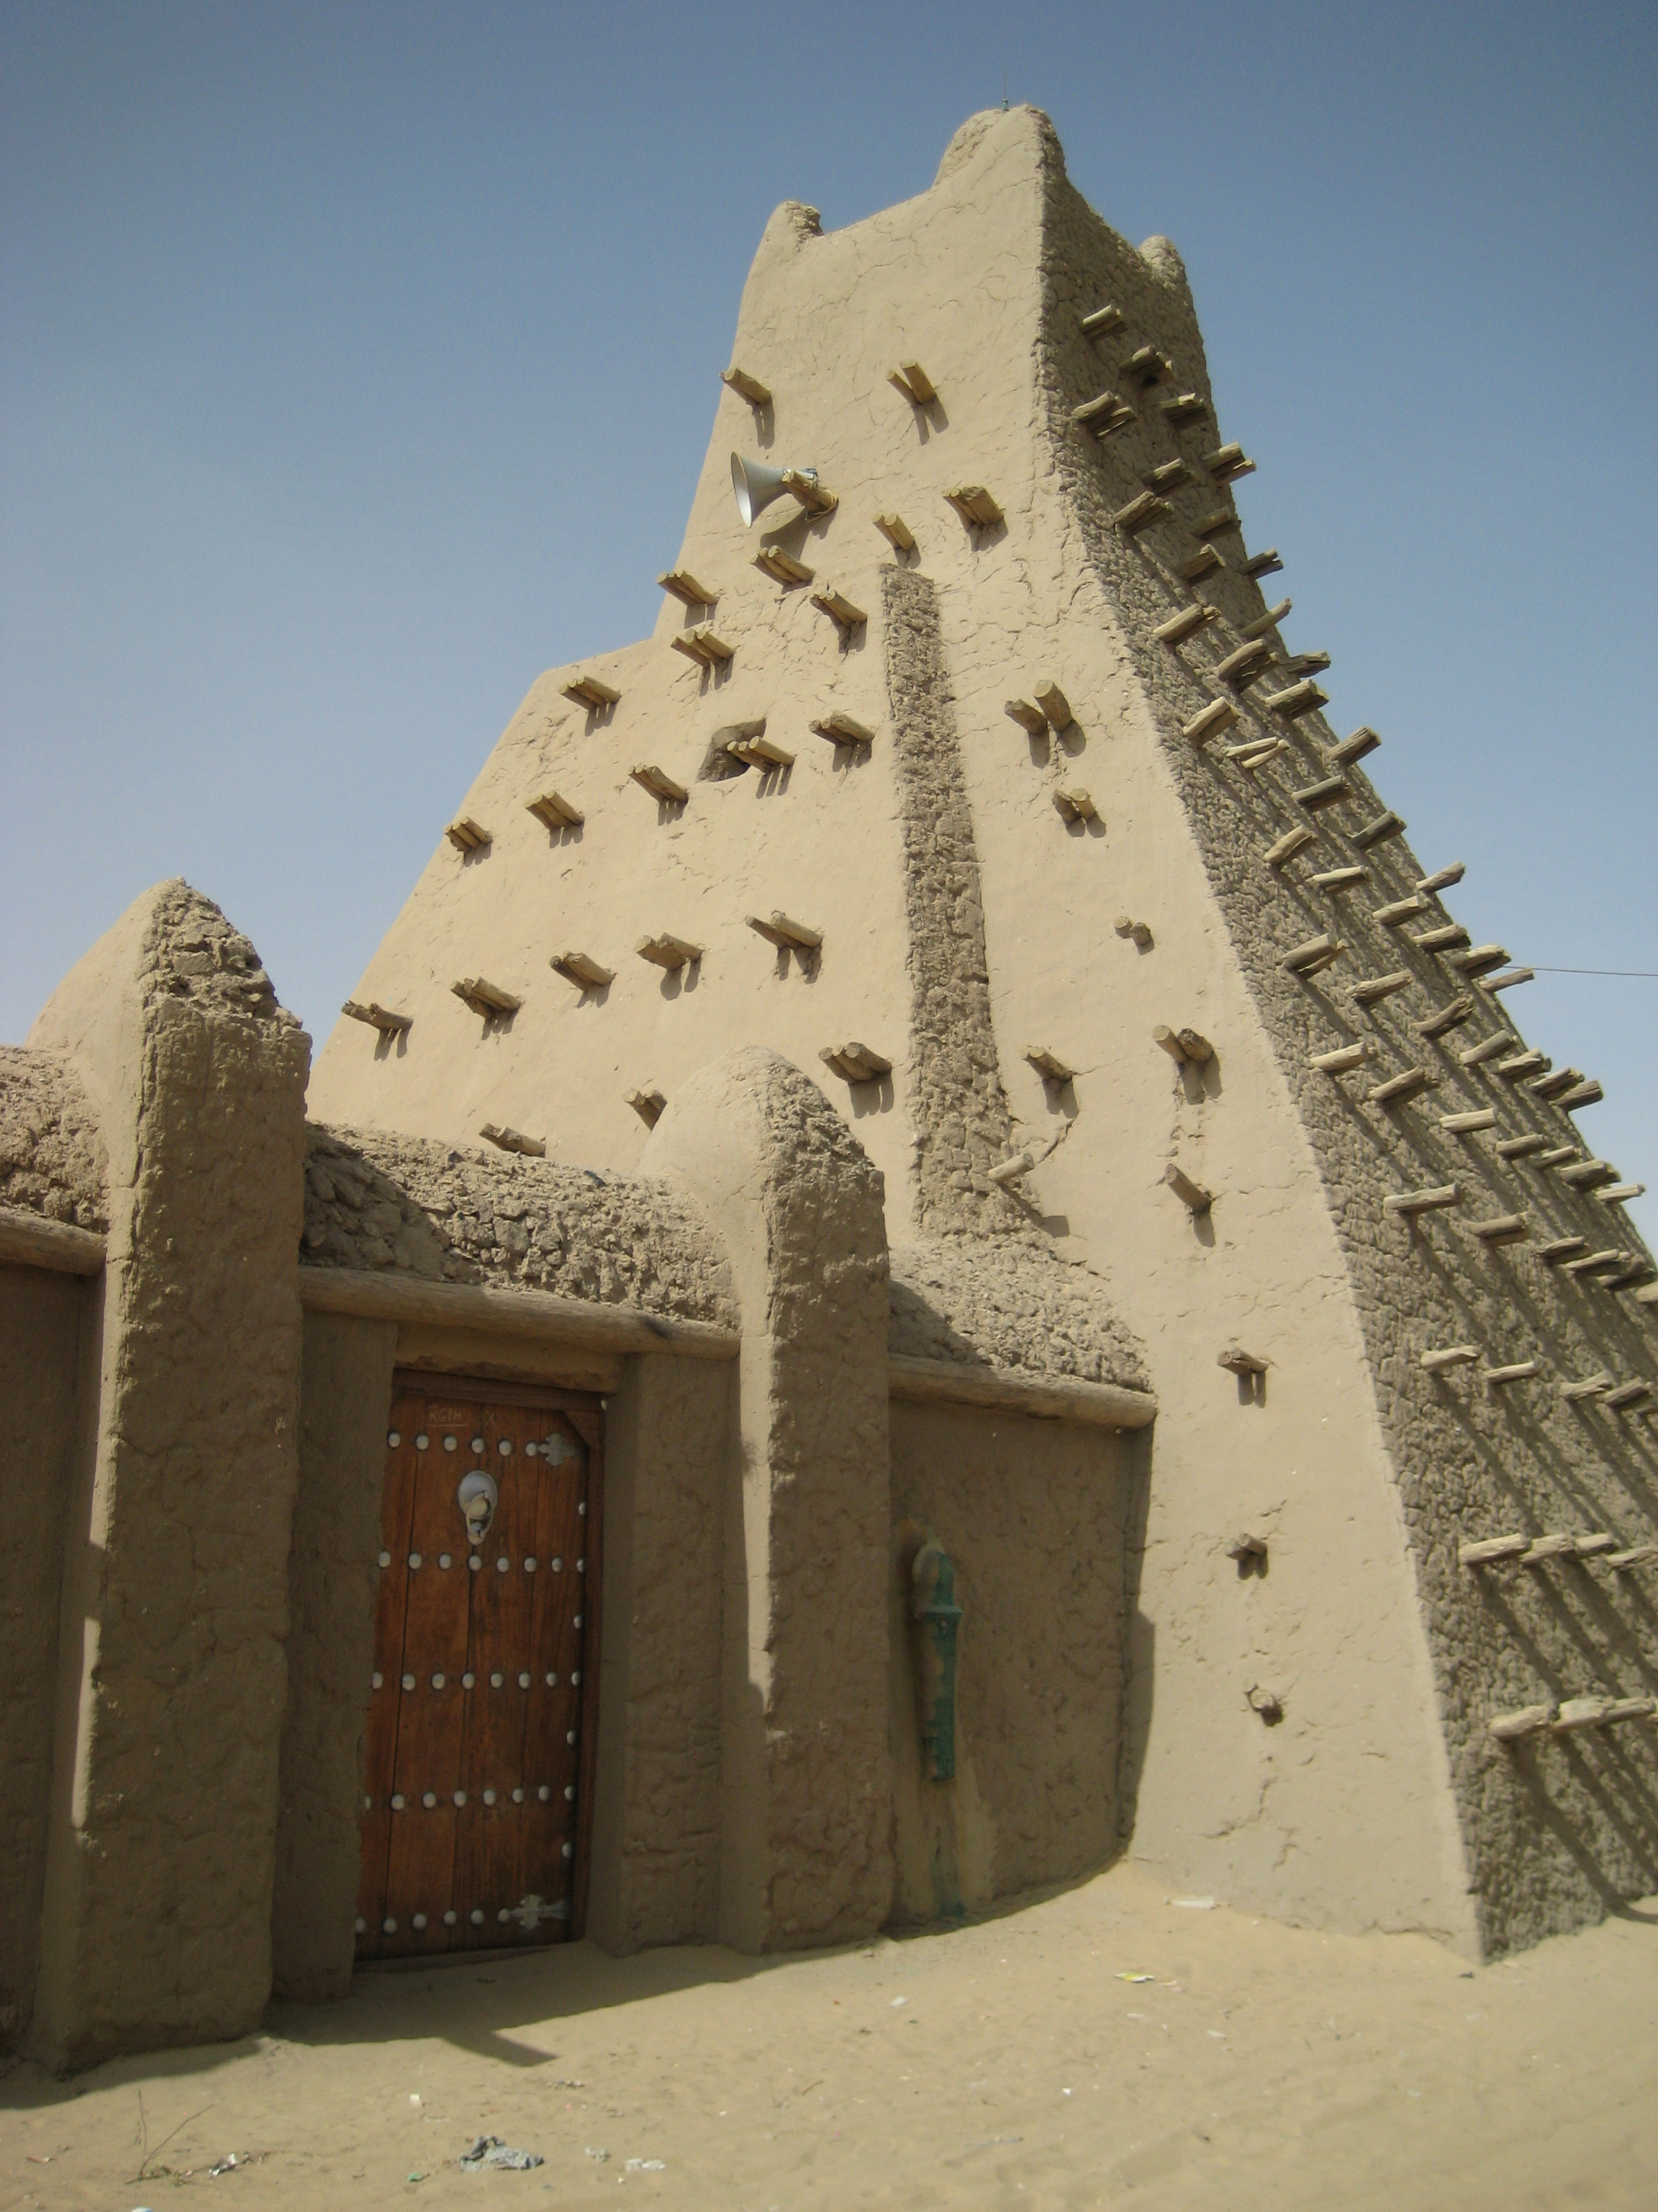

A central mosque of Timbuktu – note the pyramid style, scaffold and mud (adobe) architecture unique to this region of Mali and the Moroccan style door with silver inlays.
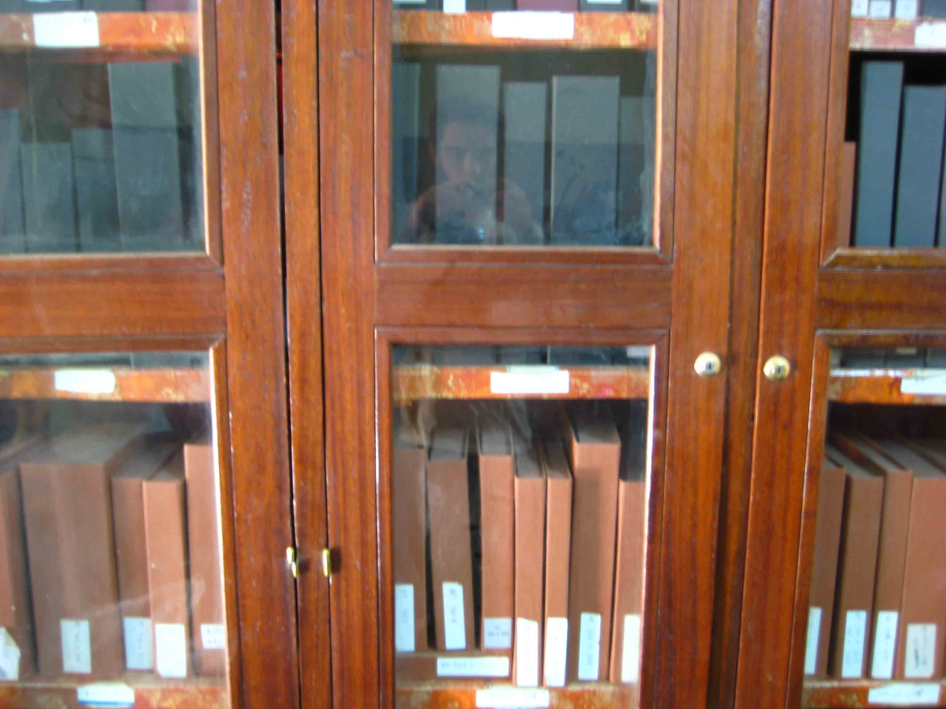
The Mamma Haïdara Commemorative Library in Timbuktu: Storage and display cabinets housing the manuscripts with glass and wood doors and protective cardboard exteriors for the artifacts.

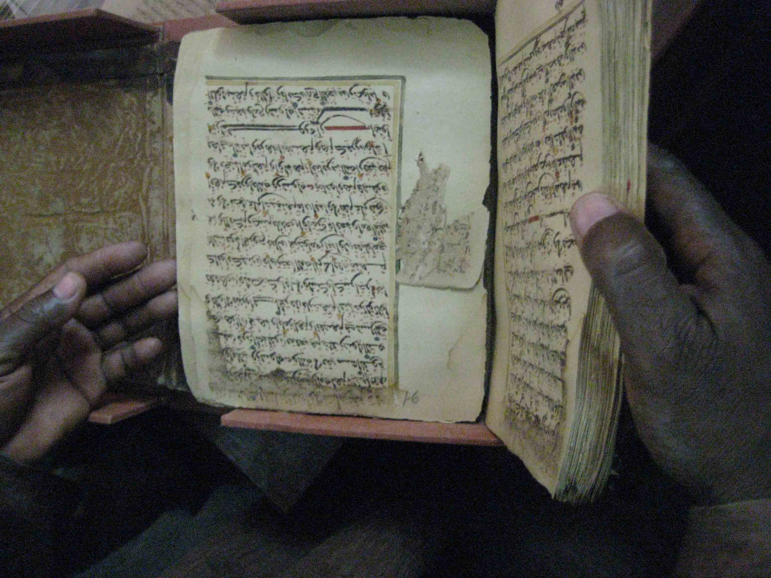
An Islamic manuscript displayed by the librarian. The handling of manuscripts is a practice fundamentally removed from Western archival methods but essential to the Muslim community’s relationship to the manuscripts.
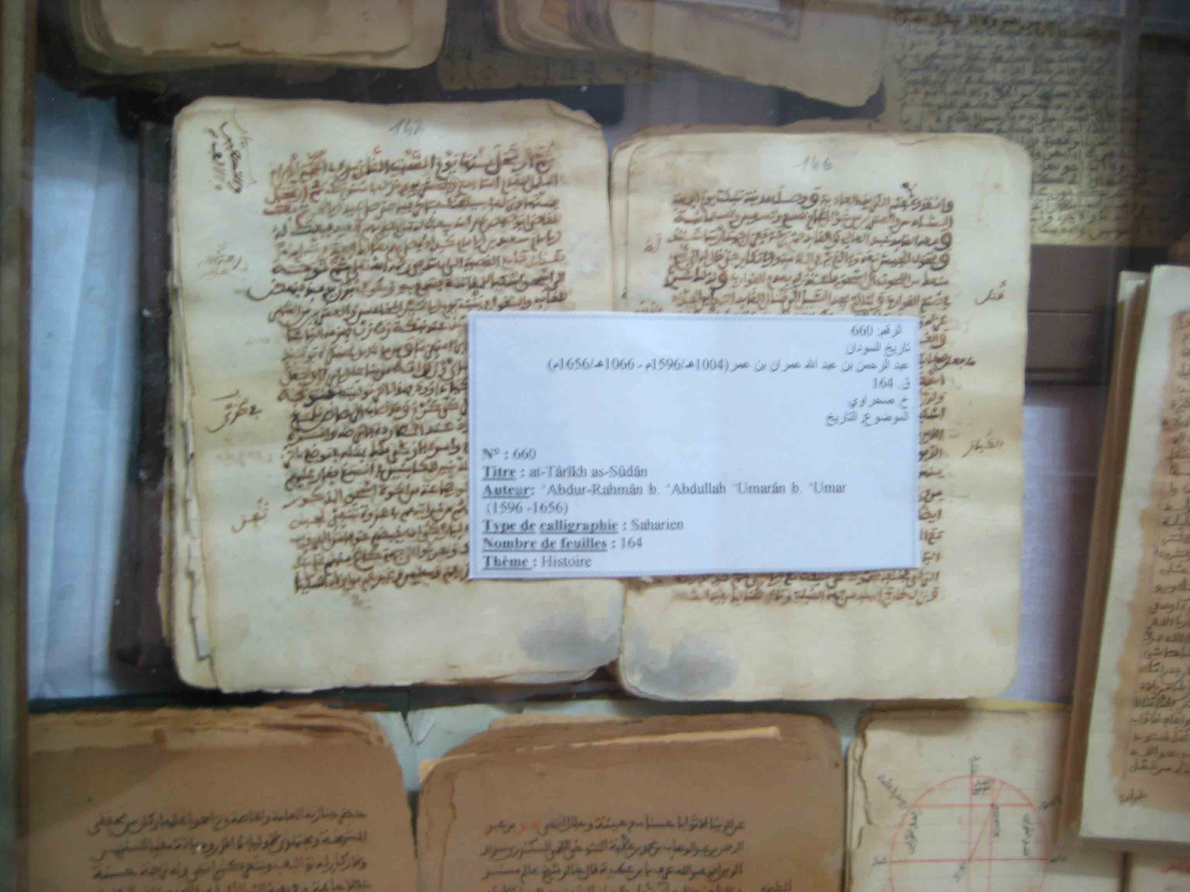

Islamic manuscripts on display at the Mamma Haïdara Library: Above, a 16th century manuscript and below, manuscripts with text and images relating to astronomy. These photos were taken through the glass of the center display table at the library.

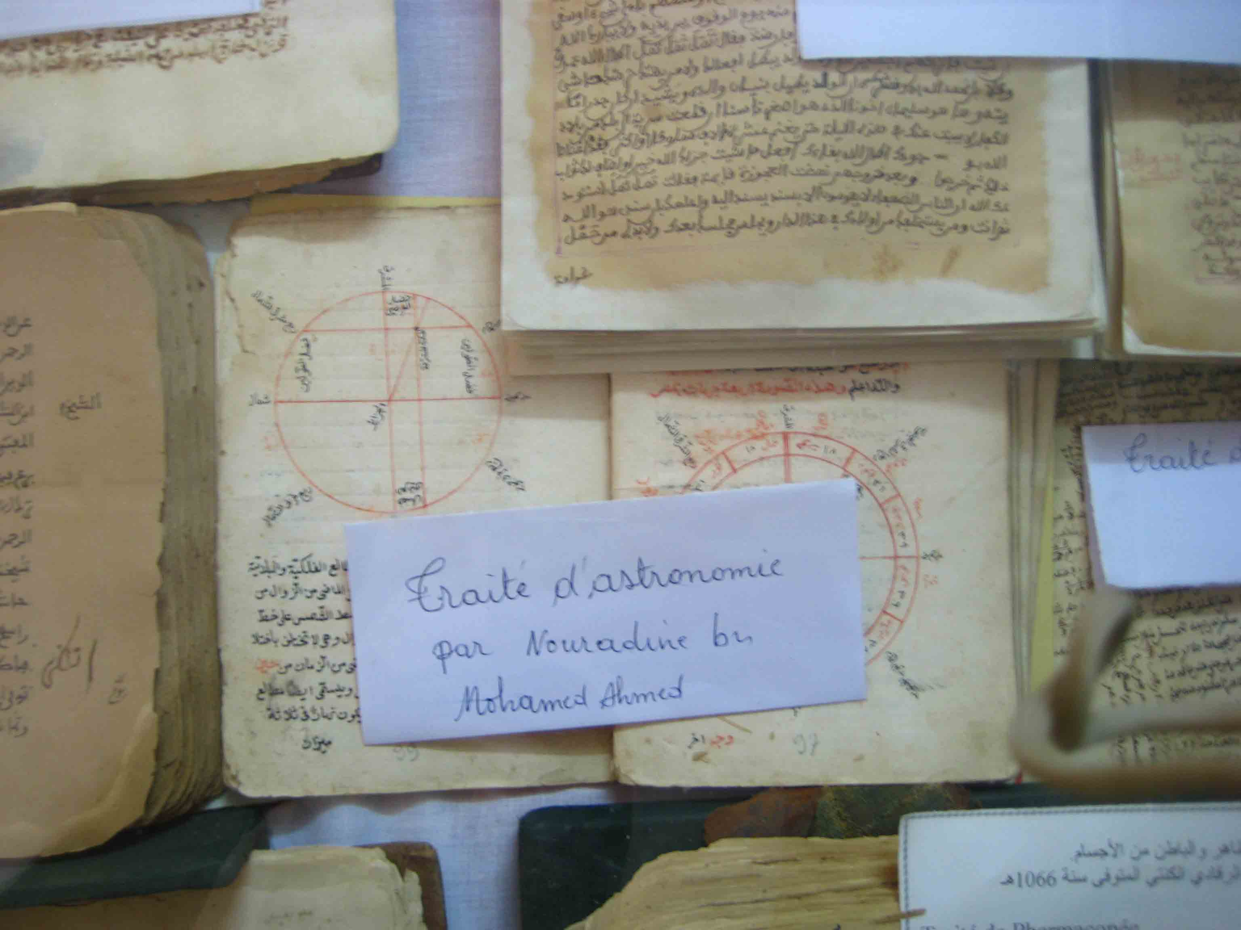

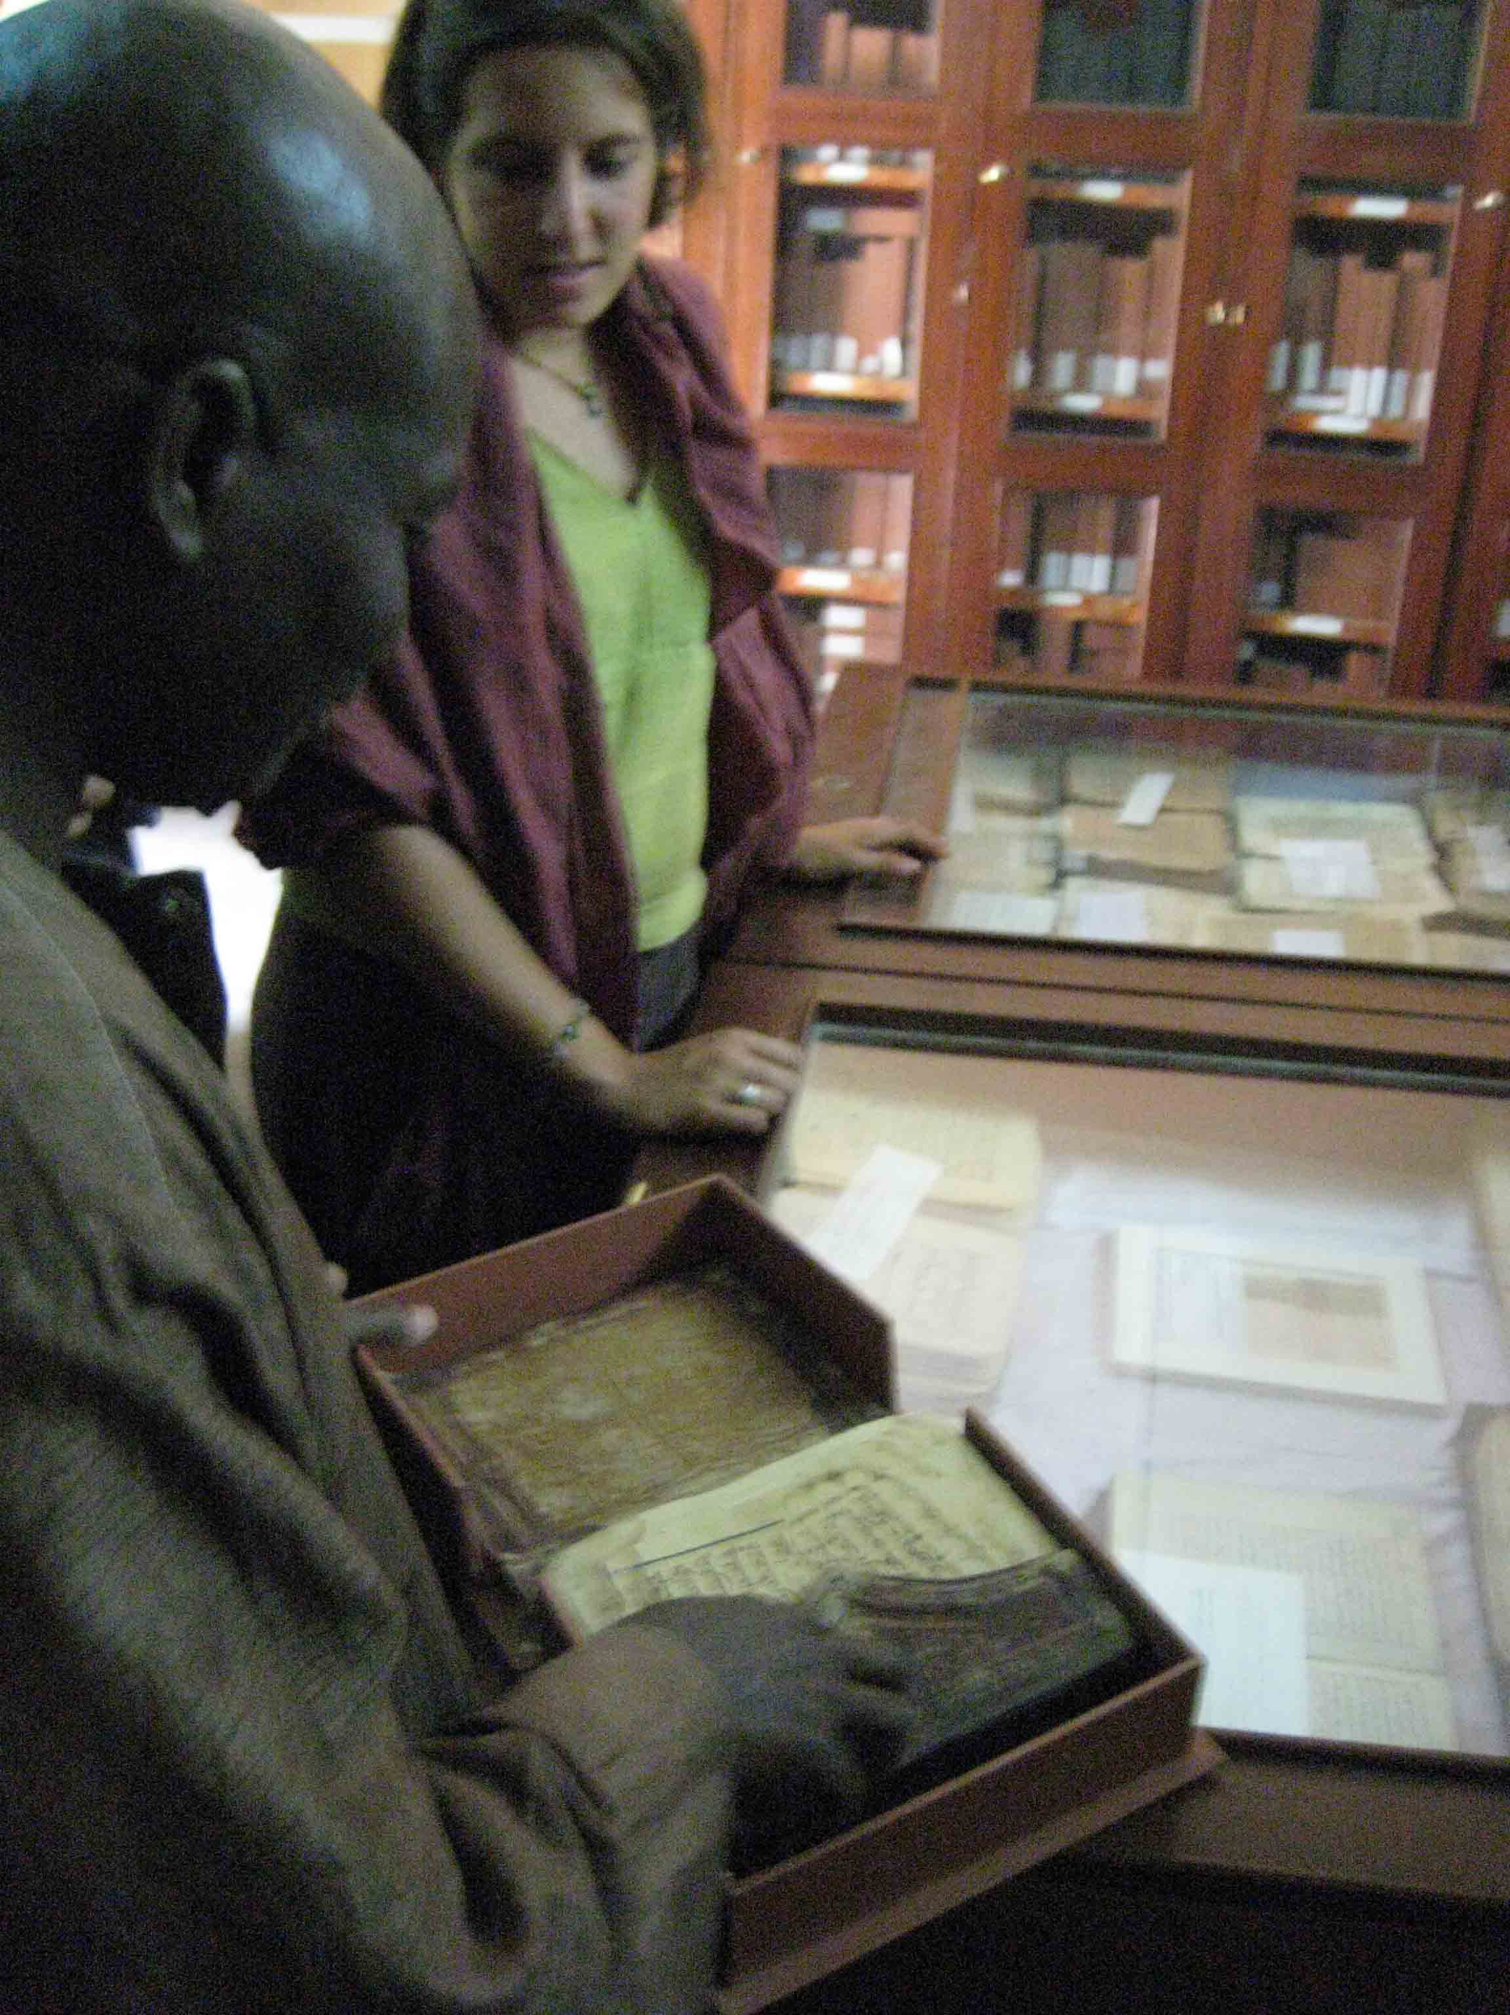
Above, the librarian returning manuscript to the exterior cardboard case. And finally, below is a photo of my boyhood dream coming true: a camel caravan trip into the Sahara. Touristy? Definitely. Regretted? Absolutely not.

This is a practice that is reflected in many written accounts of the Other by early Western anthropologists in the colonial era. I am reminded of a processual (structural) archaeologist’s warning: beware of approaching a site with your mind fixed on what you want to find, because whether it actually exists or not, you’ll probably find it.
The Robert Goldwater Online Library Resource. May 19, 2009. http://goldwaterlibrary.typepad.com/rgl/conservation/
Chicago Tribune, Apr 9, 2001.
Stoler, Ann. Colonial Archives and the Arts of Governance. Archival Science, 2: 87-109, 2002.

